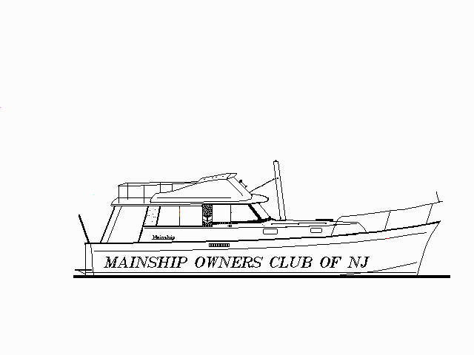 H. WARREN TIMM
PO Box 66 (130 NE 26th Av, Ap301)
Waretown, NJ (Boynton Beach, FL)
08758 (33435)
609-693-4513 (561-739-9100)
"tinytimm2@aol.com"
TICES SHOALS NJ RAFTUP
Saturday, August 25th, 2001
August 15, 2001

Dear Mainshippers;

Summer is drawing to a close, so it’s time to get together with good friends once again and have a day on the water before temperatures start to plummet. After last week’s heat wave, many are probably wondering “just where was HE last week”? But there’s no doubt that Saturday the 25th will be lots better than our June raftup, at least weatherwise. On that date, we had three boats headed for our party, but we called it off by radio before a brisk front came through. No matter, let’s get together once again and have a great day, topped of by dinner at the Captain’s Inn afterward. We look forward to having you with us!

And on October 20th, there will be raftup of Mainships on the west coast of Florida at Pelican Cove being organized by Dave Brooks (904-726-7651)(brooksd2@hotmail.com). Nine have signed up already, so this might be the largest raftup of Mainships on the east coast. Dave always has room for more and is looking forward to hearing from all who would like to attend.

What’s new in this world? From Jim Krueger, there’s lots that’s happening at Mainship. Jim reports that Yanmar has revised its terminology on its engines, calling the old 170 now a 190, the 230 will be a 240, the 300 leaps to a 315, the 350 will be a 370, and the 420 will now be known as a 440. Jim says that this is to reflect the horsepower put out by these engines, but the concept of relabeling is not unknown to marine manufacturers, is it?

Jim also advises that the 30 and 34 Pilot series will have Sport and Luxury editions added to the product lines, and a pipe frame hardtop will be offered for the 30 as well as a marlin tower for the 34’s. A stainless steel package is also available for these boats which includes exterior rails and portlights for all models. The 34 Pilot will offer twin Yanmars as an option this fall for those wanting more speed. Hull design will be different to achieve the speed, and testing is presently under way. And finally, there may be a 48 Mainship in the future. Mainship has built a 48 foot single engine trawler for Warren Luhrs who will be testing it as a long-distance boat of the future. And finally, sales of Mainship trawlers this year has increased 36% over last year. Nice to hear that they are selling that many more new boats!

John Padmore, fed up with changing fuel filters, has found that by installing a Cap’t Wil fuel setup involving using paper towels, he can go lots farther before replacing the roll of paper towels, and his engine is running like a charm since the addition. It cost John around one BU (Boat-Unit, or $1,000) and two days of routing hoses to install it, but now he can go through the season using only two rolls of towels instead of the many Racor changes that were necessary on his boat last year. John would be happy to provide details if you contact him at jmpadmore@yahoo.com.

Everyone who is young at heart today is looking for a good turbo! For those of us with boats, however, Don Gagne reports that Herman Stabile (908-295-0040) has a reconditioned turbocharger for a 200 Perkins available for sale. Don also reports that Mack Boring claims to have some Perkins parts available at their facilities. They used to handle Perkins, and may have what you are looking for. He also reports that GlassPlus will remove the “yellow” stains on vinyl plastic windows – but for scratch removal, he suggests that Micro Surface Finishing Products (800-225-3006) has a product (KR-70NG, $7.95 + $7 shipping) that will refinish vinyl windows. To remove scratches, they suggest their #3KCLRV which is $59.95 plus $7 shipping.

Getting that gloss might be a “forever” type of job, but John McCallum operates a boatyard, and has found that by washing the hull with detergent and MaryKate On-and-Off hull cleaner followed by a power buffing with 3M restorer wax, a durable finish is obtained in this manner. After three applications, the hull looked almost new and held up for most of the year.

Who forgot to put some money in the meter? Back in days of old when coins were required in electric meters to pay for electricity, power outages were solved simply by inserting another quarter. Those of us with Crossfire gensets occasionally find moments when our units just don’t produce any power, regardless of the running machinery, etc. Dave Mathias relates that to restore power in these units, all one needs to do is to touch the top of one of the two diodes in the alternator with a wire from a 9V battery to restart generation (make sure the negative lead is connected). Some have even connected a wire here and fed it from the 12V battery through a resistor that will drop the voltage to 9 volts - and when the lights go out (depending upon local circumstances, of course!), energize this wire via a push button. With talent like this around, Thomas Edison wouldn’t have had a chance!

Now just where is that anti-freeze disappearing to? Randy Smith has a 200 Perkins in his boat, and was on a cruise in the Bahamas when his engine started to overheat. Before the trip, his engine was running flawlessly for years; and he found that now he was losing coolant from his engine and also had some water in the cylinders while still in the Bahamas. A consultation with a mechanic suggested that the Range 4 engines with the aluminum manifolds had casting problems and occasionally sprung leaks. Perkins replaced these if discovered in the first three years, and gave partial reimbursement in the 4th and 5th years, but for engines older than that – you were on your own. Not wishing to deal with repairs of this nature while so far from home, Randy had his boat towed to his home port, Fort Pierce, and then had the manifold replaced. The cost of a new manifold for these engines was 4.5 BU ($4,500), and let’s not even discuss the cost for the tow back from the Bahamas to Fort Pierce. Randy did the labor, but it was still an expensive proposition. His advice to all with the 200 Perkins engines is to keep an eye on your manifolds and coolant levels. Although there was no sign of a failure on testing before the cruise, appearances are not always reliable. If water begins to show up in cylinders of these engines, it is most likely the manifold that is giving the problem. We must also be aware that if water does get into the cylinders while the engine is at rest, cranking the engine can bend internal parts and create the strong desire to have the engine rebuilt. A stitch in time saves nine, as the old saying goes. If your coolant level is dropping, there’s usually a place that it is going. Better to be safe and find out where before anything happens. Another observation of Randy Smith that merits our consideration is that it is always nice to have another boat along on lengthy cruises to provide support in case of either boat breaking down. A word to the wise . . .

Ever try to replace those folding flybridge seats on the earlier Model I’s? The newer ones in the catalogs fold out only one way, and are a challenge to mount in the confines of our bridges. Nick Senzamici has found that Price Custom Products (828-322-2211) makes seats the same size as our originals, and will refer you to a local dealer if you wish to contact them. As for the Captain’s chairs, all the new ones are mounted on pedestals that are 2 7/8” in diameter instead of the 2 ½” pedestals that were used on original hardware. If you wish to use the original pedestal, you can remove the slide mechanism from your original chair and mount it on a new chair. Less expensive that way, and you don’t need to either buy new hardware or remove the old pedestal.
Looking for a New Home Dep’t.
1982 Model I, 165 Perkins, Onan 3.0, fresh water kept, listed by Duke Lorzing: Eagle410jj1@aol.com
1980 Model I, 160 Perkins, Onan 3.0, lots of equipment listed by Chet Wooldridge: Chetw@haengineers.com
1981 Pilot House 40, twin Perkins 165’s, Onan 7.5, great condition by Irwin Hurwitz: Ihboat@aol.com

Our best wishes to all for an enjoyable summer of cruising for the remainder of our season! (at least up north!)

