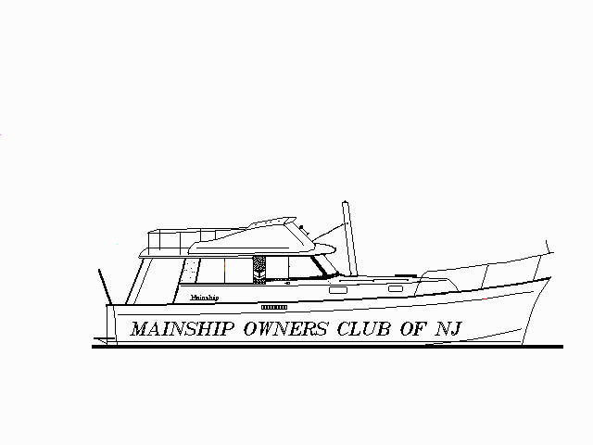 H. WARREN TIMM
PO Box 66 130 NE 26th Ave, Apt301
Waretown, NJ Boynton Beach, FL
08758 33435
609-693-4513 561-739-9100
"tinytimm2@aol.com"

October 30, 2000

Dear Mainshippers;
Now that it is fall here in the northlands, how nice it would be to get together with other members of our group for a dinner every now and then. Let’s plan to do this every third Saturday of the month at the Captain’s Inn in Forked River for those in the NJ area. Let’s meet at 1800 hours at the bar and then have dinner at our leisure starting on the third Saturday in December (12/16). We look forward to saying hello to all and enjoying an interesting evening of conversation.

A mid-winter gathering of Mainshippers??? Jay Leonard and Greg Hart (business number – 843-744-0404) are making arrangements for a mid-winter confab of those in our various groups along the east coast in Charleston SC for the weekend of February 2nd, 3rd and 4th. A special deal has been obtained with the Hilton Hotel there for our members, and you can join the group by reserving your room at the Hilton ($99/night right now, but less if we show up in numbers) by calling 888-856-0028 and mentioning that you are with the Mainship group. Rooms may also be had at the Quality Inn (800-704-4480) for the same price. The Charleston Harbor Marina (which is located at the Hilton) is offering slips to boaters who want to bring their boats. They may be contacted at 843-856-9996. Please mention "The Mainship Group" when making your reservation so we can get slips next to each other. Transient rate is $ 1.31 per foot.

Winter weather in Charleston can be highly variable, but if conditions are right, a few of our members there have volunteered to offer our visitors a boat tour of the harbor. A Friday night dinner at a barbecue place called Sticky Fingers will be followed by a Saturday night Oyster Roast, and of course, lots of interesting people to talk to. What a grand idea to make a long winter seem so much shorter!

We oftentimes learn through experience.
- Ed Crooks has found the leak in his water system. It was the safety valve on the water heater, and because the valve is connected to a short hose into the bilge, it wasn’t readily noticeable.
- While anchored out, he also wondered why his genset sounded different, and found that the 1” exhaust nipple wasn’t corroded on the outside, but it was on the inside causing the leak.
- He also had a shift cable failure and found that if one cable jams, the other control will not work. Since replacing both cables with Teleflex TEXTREME cables, one 15 feet, and the other 34 feet, his shifters work easier than brand new.
- And on a final note, Ed installed a 4” Nicro Power Vent 3000 in the forward part of the main saloon. The vent is solar powered and does a nice job of keeping cabin temperatures down when the boat is left unattended and closed up. If anyone would like details on the installation, Ed (616-547-4990) would be happy to provide them.

Don Gagne, never to be satisfied with the status quo, had a bit of engine overheating on his 160 Perkins and turned detective to solve the mystery. After cleaning every piece of plumbing that even came close to the salt water side of his engine without results, Don found that the rubber gasket that sits in a recess in the strainer housing had expanded, and become difficult to seat all around. This permitted air to be drawn in along with the cooling water and resulted in a reduction of cooling volume. By using a liberal amount of grease, the gasket could be made to seal again. If seeking a replacement gasket – be careful! A gasket recommended in a distributors catalog (RWS5) was much thicker and permitted debris to bypass the strainer.
Word from the source! Sherlock - is it a 350 or a 390? Jim Krueger from Mainship advises that when the 350 trawlers were first introduced, they didn’t have the integral swim platform that is now supplied with the newer boats. That boat was 35 feet long without the platform, but today’s boats with the platform measure 39’ 9”. Although boats were made for a few years with the platform and called 350’s, that number was changed for the 2000 model year to be consistent with how the boat was marketed in Europe, as well as reflecting the 25 other changes made to the boat for this model year. And Jim also advises that two of the 390’s had been shipped from the factory on trailers without draining the mufflers since no freezing was expected during the trip. These boats were loaded onto the trailers in a bow-down position, and during down grades, water from the mufflers was able to enter the cylinders of these engines resulting in hydro-lock. Upon learning this, Mainship honored their guarantees and replaced both engines with new ones. Caterpillar has advised Mainship that their installation meets all Caterpillar standards. The bottom line is that Mainship had two customers with problems and Mainship took care of them, and they now drain exhaust systems prior to shipment regardless of season as well as shipping all boats mounted level on trailers.

Fuzz only lasts so long, and on the earlier 34’s the material in the window tracks of many of our boats has begun to change a tad in character. Dave Darrow has found that this material is called Schlegal, and can be supplied by Taylor Made System of New York who make complete window systems for boat manufacturers. They make two types of Schlegal, and will send you samples if you ask. Part # 4965390 is 16 cents per foot and fits the outside edge of the track, and part # 4966110 is 28 cents a foot and goes on the inside edge of the track. Their phone number is 518-773-0636.

Now where is that drip coming from? Simon Josowicz found some leaks around his windshield area, and fixed them in a two step process. To solve the gasket leaks, he lifted the gasket edge and squirted black silicone sealer in the gap, letting the gasket press it into a seal. Trim the material off after hardening with a razor. And for those leaks through the windshield frame, Simon removed three screws from the frame at a time, squirted black silicon into the middle hole until it came out the two others thus filling the gaps with silicone, and then replaced the screws until he got all around the frame. Simon advises to use a lot of pressure on the caulking gun to fill the cavity, and that inexpensive black silicone found in hardware stores works fine since it isn’t exposed to the weather. It has been 10 years now since any errant “drips” were found aboard the TROMBO.

Richard Kimble (who lives in Nassau and keeps his boat there) oftentimes cruises to places where fresh water is rather expensive and wanted to expand his water supply aboard his 34 foot boat. To make room for more tank capacity in the lazarette, he relocated his fresh water pump on the starboard side of the genset, obtained a new square water heater which he mounted on the port side of the genset, and then removed his old 40 gallon tank. He replaced this with two Kracor tanks listed in the Lewis Marine Supply Catalog that were 21.75” wide x 30” long x 13.75” high, mounted side by side. These were a little bit higher, came further aft, and fit into the space if the principle of “togetherness” was exercised during installation. It’s a bit harder to grease the shaft bearing, but it can be done. Richard finds that by drawing of each tank separately, he can use this to trim his boat. If you have any questions on how this was done, Richard would be happy to supply the details. His address was listed in the May Roster additions you received, and his email address is rkimble@bahamas.net.bs.

One of the great opportunities that are offered to those who have Mainships is the ability to get together with some of the nicest people that many of us have had the occasion to meet. Take advantage of these occasions as often as you can, to find yourself richly rewarded with the pleasures of meeting with and talking with our interesting members.

